**Time Series Data Processing**

1. Grab images from a live webcam. Save a couple of images.
2. Write some code to calculate the average intensity of the camera image. It should grab an image, and return a single number with the average intensity, as a floating point number.
3. Make a plot of the average image intensity over time. It should look something like this  
   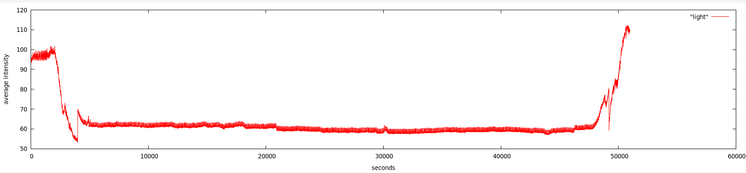  
   Take a reading about once a second, and plot it against time, in seconds. time to convince the TA that the code does the right thing.
4. Wrap up your code in a class, and wrap up the code from the previous question in a function of this class.
5. If you zoom in on these data, you'll notice that they're a bit noisy  
   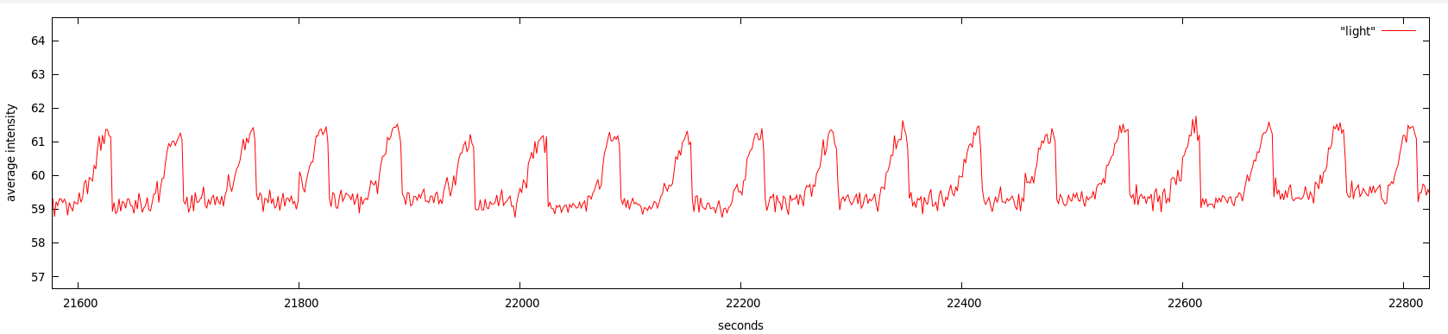  
   Write some more code that returns the *filtered* average intensity. You can use any filter you like, and any size, but you should pick one that causes the graph to be somewhat smooth. Provide a function that returns the filtered average intensity.
6. Write a class function, called daytime that returns True if it's daytime, and False if it's night. Base the output of this function on the average intensity of the image, not on the actual time.
7. Write a function that grabs an image and calculates the most common color in it. The function should take no arguments, and return the most common (r, g, b) tuple. What color is this? What proportion of pixels have this color?
8. Write a function that detects motion in the image stream. This function should take no arguments. It should take two images, with a short delay between them (to make sure that they're actually different images). Then, it should calculate the differences of the corresponding pixel values in the two images, and return the average pixel difference. Write a function called motion that returns True if there's movement on the quad, and False otherwise.
9. Write a function called event that returns True if there's an event happening on the quad, and False otherwise.